WEEK 1
Module 1 - Design Patterns and Principles
What & Why, The SOLID Principles of Object-Oriented Programming - The Single Responsibility Principle, The Open Closed Principle, The Liskov Substitution Principle, The Interface Segregation Principle, The Dependency Inversion Principle
SOLID principles were introduced by Robert C. Martin in his 2000 paper “Design Principles and Design Patterns.”
These concepts were later built upon by Michael Feathers, who introduced us to the SOLID acronym. And in the last 20 years, these five principles have revolutionized the world of object-oriented programming, changing the way that we write software.
Design principles encourage us to create more maintainable, understandable, and flexible software. Consequently, as our applications grow in size, we can reduce their complexity and save ourselves a lot of headaches further down the road.
- Single Responsibility
- Open/Closed
- Liskov Substitution
- Interface Segregation
- Dependency Inversion
Single Responsibility
A class should only have one responsibility. Furthermore, it should only have one reason to change.
Ex:
Imagine a Chef who also has to wait tables, wash dishes, and manage accounts.
- He’s overwhelmed, mistakes pile up, and the restaurant suffers.
- If each person just did one job — Chef cooks, Waiter serves, Accountant manages money — everything runs smoothly. Lesson: A class should have only one responsibility, just like each worker should have one clear role.
- Testing – A class with one responsibility will have far fewer test cases.
- Lower coupling – Less functionality in a single class will have fewer dependencies.
- Organization – Smaller, well-organized classes are easier to search than monolithic ones.
Open for Extension, Closed for Modification
Classes should be open for extension but closed for modification. In doing so, we stop ourselves from modifying existing code and causing potential new bugs in an otherwise happy application.
Ex: You own a coffee shop. Customers suddenly want pumpkin spice lattes.
- If you keep rewriting your old coffee recipe every time, chaos ensues.
- Instead, you extend your menu with a new recipe card, without changing the old ones.
- That’s OCP: your system is open for extension (new drinks) but closed for modification (old recipes stay intact).

Liskov Substitution
If class A is a subtype of class B, we should be able to replace B with A without disrupting the behavior of our program.
Ex:
Imagine you hire a Housekeeper.
- You expect them to clean, cook, and do laundry.
- That’s the “contract” you agreed upon.
Now, suppose you hire a Robot Housekeeper (a subclass of Housekeeper).
- It can clean and cook perfectly.
- But when you ask it to do laundry, it says: “Error! I don’t do laundry.”
This breaks your expectation. You thought any “Housekeeper” could do laundry, but this one doesn’t. That’s a violation of LSP — the subclass didn’t honor the promise of the parent class.
Interface Segregation
It simply means that larger interfaces should be split into smaller ones. By doing so, we can ensure that implementing classes only need to be concerned about the methods that are of interest to them.
EX:
You hire a Handyman with a giant contract: plumbing, electrical, carpentry, painting.
- But you only need plumbing.
- The handyman insists you pay for all services, even unused ones.
- Instead, you split into smaller contracts: Plumber, Electrician, Carpenter. Lesson: Clients shouldn’t be forced to depend on methods they don’t use.
Dependency Inversion
The principle of dependency inversion refers to the decoupling of software modules. This way, instead of high-level modules depending on low-level modules, both will depend on abstractions.
You buy a TV that only works with one brand of remote.
- If the remote breaks, you’re stuck.
- Better design: TV works with any remote that follows a universal standard.
- That’s DIP: high-level modules (TV) depend on abstractions (Remote interface), not low-level details (specific brand remote).

Commonly used Design Patterns GoF, Creational Patterns - Singleton Pattern, Factory Method Pattern, Builder Pattern; Structural Patterns - Adapter Pattern, Decorator Pattern, Proxy Pattern; Behavioral Patterns - Observer Pattern, Strategy Pattern, Command Pattern; Architectural Patterns - Model-View Controller (MVC), Dependency Injection
Pattern | Kingdom Story | Remember
Singleton | One King | One object only
Factory | Toy Factory | Creates objects
Builder | Burger Chef | Build step-by-step
Adapter | Charger Adapter | Connect incompatible things
Decorator | Coffee Toppings | Add features
Proxy | Security Guard | Control access
Observer | Newspaper Subscription | Notify subscribers
Strategy | Travel Options | Choose behavior
Command | King's Orders | Request as object
MVC | Bank App | Separate data, UI, control
Dependency Injection | Blacksmith gives sword | Dependencies come from outside

Create Objects → Singleton, Factory, Builder
Modify Structure → Adapter, Decorator, Proxy
Manage Behavior → Observer, Strategy, Command
Organize Application → MVC, Dependency Injection

1. Singleton pattern
Singleton Pattern ensures that a class has only one instance and provides a global access point to that instance throughout the application.
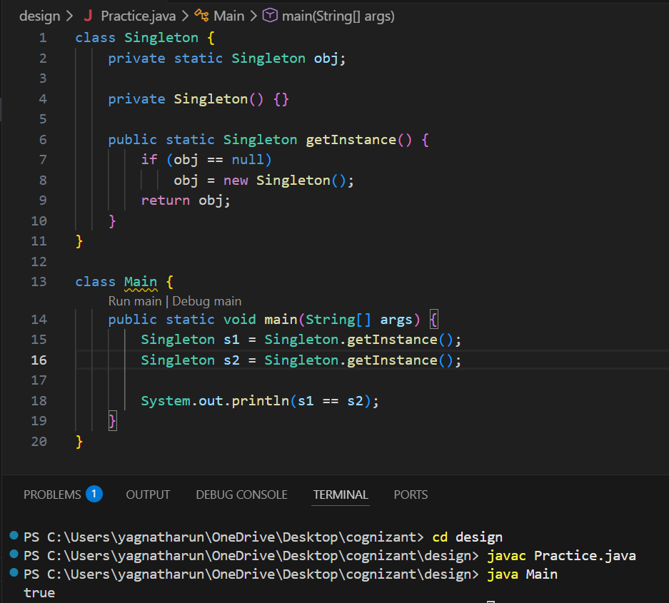

2. Factory Method Pattern
Factory Method Pattern defines an interface for creating objects but allows subclasses or a factory class to decide which specific object to create.
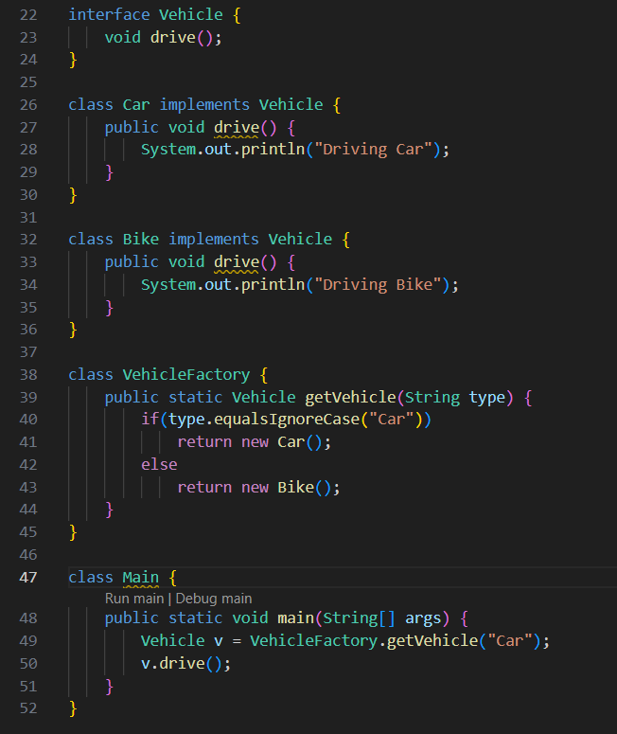
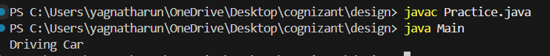

3.Builder Pattern
Builder Pattern separates the construction of a complex object from its representation, allowing the object to be built step by step.
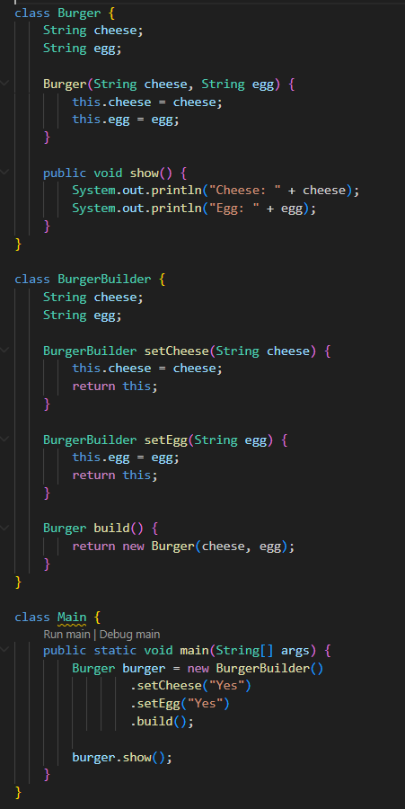
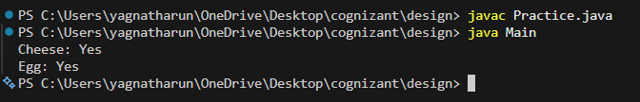

4. Adapter Pattern
Adapter Pattern allows two incompatible interfaces to work together by converting the interface of one class into another expected by the client.
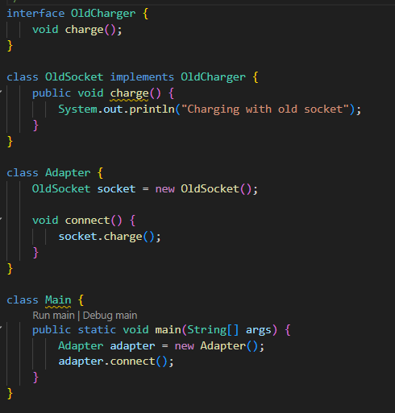
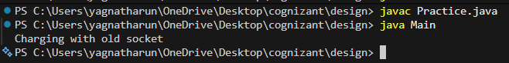

5.Decorator Pattern
Decorator Pattern dynamically adds new responsibilities or functionalities to an object without modifying its structure.
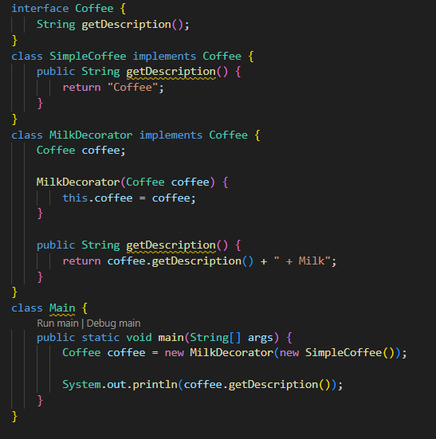
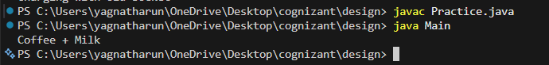

6.Proxy Pattern
Proxy Pattern provides a substitute or placeholder for another object to control access to it.
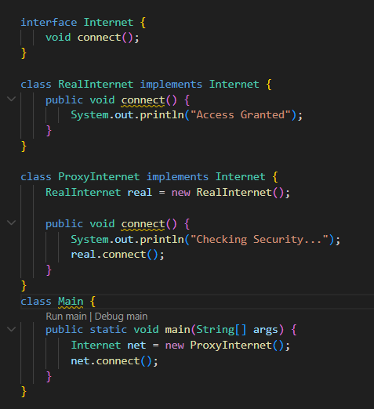
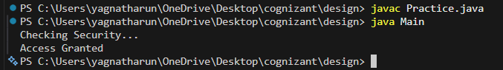

7.Observer Pattern
Observer Pattern establishes a one-to-many relationship between objects so that when one object changes state, all dependent objects are automatically notified.
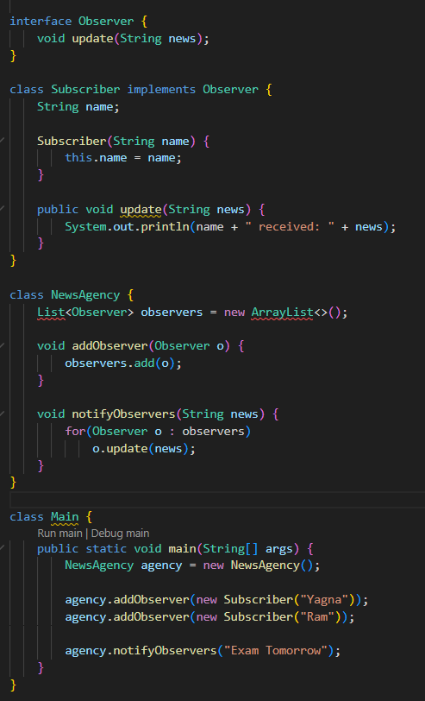
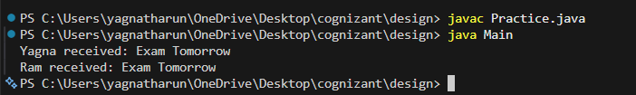

8.Strategy Pattern
Strategy Pattern defines a family of algorithms, encapsulates each one, and makes them interchangeable at runtime.
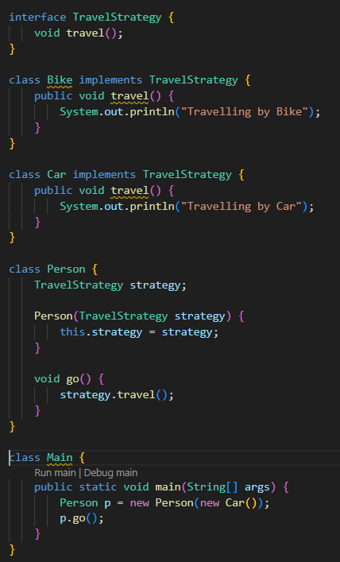
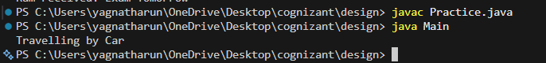

9.Command Pattern
Command Pattern encapsulates a request as an object, allowing requests to be parameterized, queued, logged, or undone.
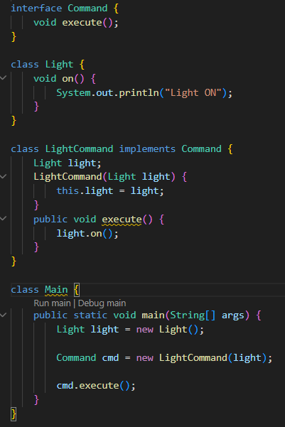
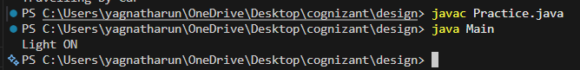

10.MVC Pattern
MVC is an architectural pattern that separates an application into three components: Model (data), View (user interface), and Controller (business logic).
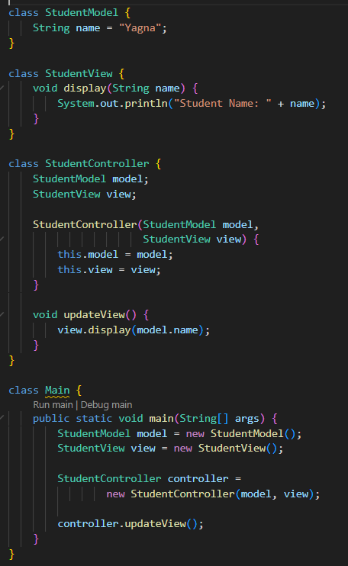
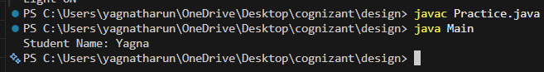

11.Dependency Injection (DI)
Dependency Injection is a design technique in which an object's dependencies are provided from an external source rather than being created by the object itself.
